**Explanation About the Tables**

**Introduction**

Database ‘BinusClass’ is designated by the creator to schedule a class as well as its lecturer, course, and the college student (in this case is Binusian) attended the class.

**Entity Relationship Diagram**

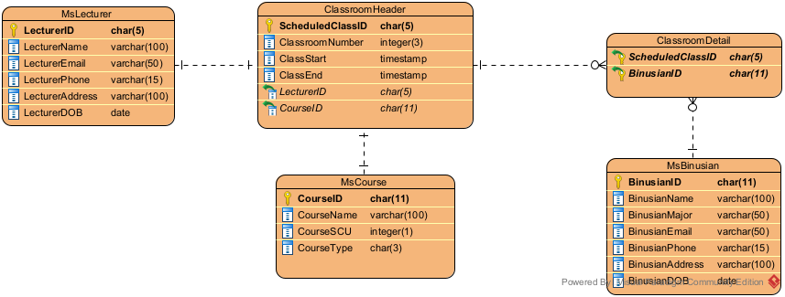

**Table MsBinusian**

|  |  |  |  |
| --- | --- | --- | --- |
| **Field Name** | **Data Type** | **Length** | **Description** |
| BinusianID | CHAR | 11 | Primary key, must be started with “BN” and followed by 9-digit number |
| BinusianName | VARCHAR | 100 |  |
| BinusianMajor | VARCHAR | 50 |  |
| BinusianEmail | VARCHAR | 50 | Must be ended with “@binus.ac.id” |
| BinusianPhone | VARCHAR | 15 | All digit and length vary between 11 and 15. |
| BinusianAddress | VARCHAR | 100 |  |
| BinusianDOB | DATE | - |  |

This table records all the Binusian (college student of the Binus University).

**Table MsLecturer**

|  |  |  |  |
| --- | --- | --- | --- |
| **Field Name** | **Data Type** | **Length** | **Description** |
| LecturerID | CHAR | 5 | Primary key, must be started with “D” and followed by 4-digit number |
| LecturerName | VARCHAR | 100 |  |
| LecturerEmail | VARCHAR | 50 | Must be ended with “@binus.edu” |
| LecturerPhone | VARCHAR | 15 | All digit and length vary between 11 and 15. |
| LecturerAddress | VARCHAR | 100 |  |
| LecturerDOB | DATE | - |  |

This table records all the lecturer of the Binus University.

**Table MsCourse**

|  |  |  |  |
| --- | --- | --- | --- |
| **Field Name** | **Data Type** | **Length** | **Description** |
| CourseID | CHAR | 11 | Primary key, must be started with 4 upper case letters and followed by 7-digit number |
| CourseName | VARCHAR | 100 |  |
| CourseSCU | INTEGER | - | Must be either 1, 2, or 4 |
| CourseType | CHAR | 3 | Must be either “Lec” or “Lab” |

This table records all the course of the Binus University.

**Table ClassroomHeader**

|  |  |  |  |
| --- | --- | --- | --- |
| **Field Name** | **Data Type** | **Length** | **Description** |
| ScheduledClassID | CHAR | 5 | Primary key, must be started with “CR” and followed by 4-digit number |
| ClassroomNumber | INTEGER | - |  |
| ClassStart | TIMESTAMP/DATETIME | - |  |
| ClassEnd | TIMESTAMP/DATETIME | - | The time must be after “ClassStart” |
| LecturerID | CHAR | 5 | References from **MsLecturer** |
| CourseID | CHAR | 11 | References from **MsCourse** |

The scheduled class's header. Containing the start and end times of the class, the lecturer lecturing at that time, and the lecture lectured by that lecturer.

**Table ClassroomDetail**

|  |  |  |  |
| --- | --- | --- | --- |
| **Field Name** | **Data Type** | **Length** | **Description** |
| ScheduledClassID | CHAR | 5 | Composite key, together with BinusianID, References from **ClassroomHeader** |
| BinusianID | CHAR | 11 | Composite key, together with ScheduledClassID, References from **MsBinusian** |

Detail of the Binusian who attended the class.